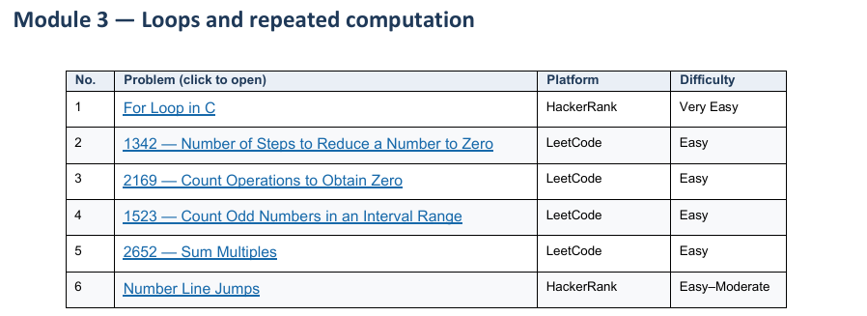
1 For Loop in C HackerRank
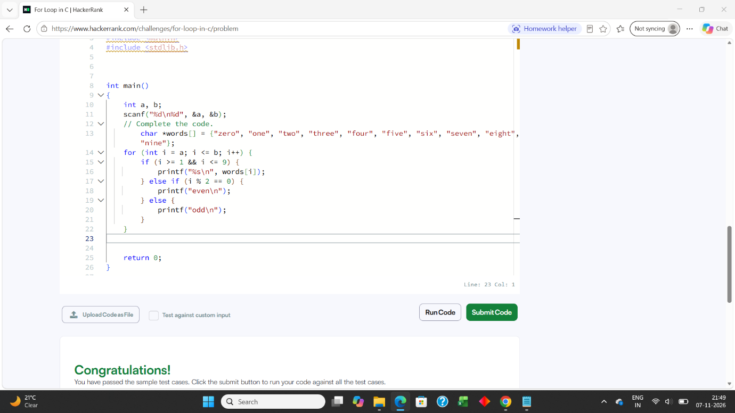

2 1342 — Number of Steps to Reduce a Number to Zero LeetCode
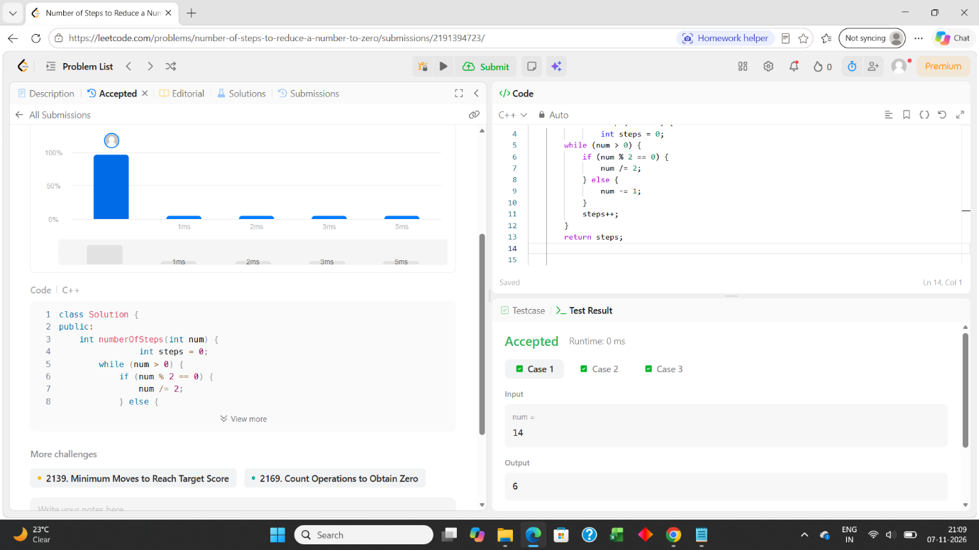

3 2169 — Count Operations to Obtain Zero LeetCode
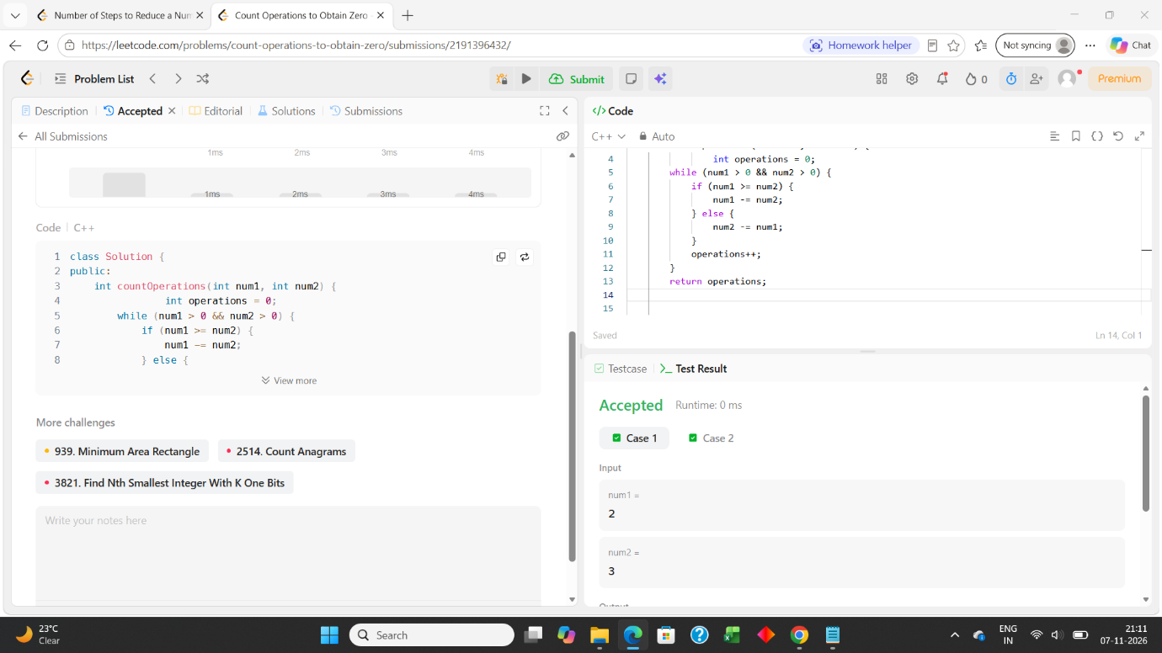

4 1523 — Count Odd Numbers in an Interval Range LeetCode
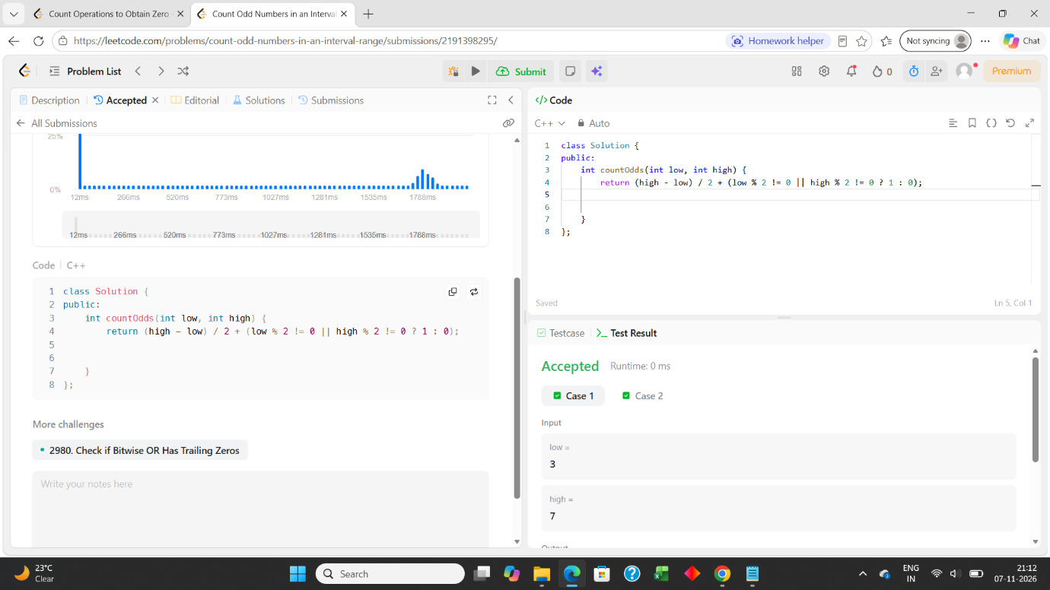

5 2652 — Sum Multiples LeetCode
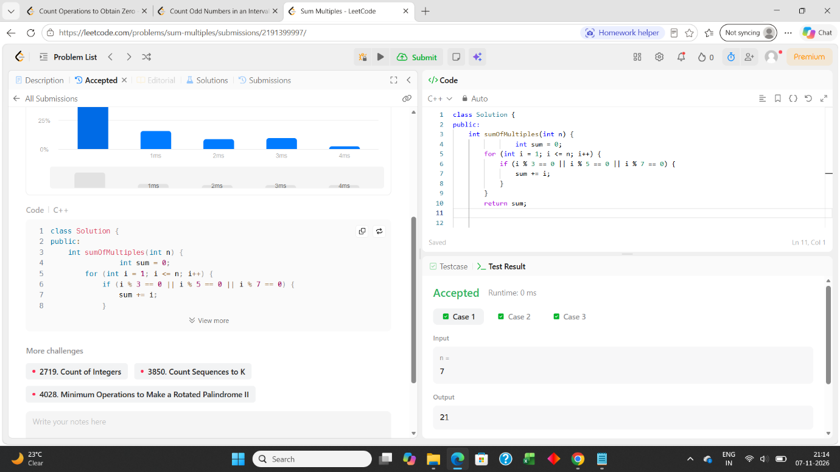

6 Number Line Jumps HackerRank


